Charlotte ISD Regular Board Meeting

March 20, 2024 at 6:30 p.m. in the 41 Rose Blvd. Bldg O

- Call to Order
- Pledge of Allegiance
- Moment of Silence
- Invocation
- Public Comments
- Public Hearing TPR
- Superintendent Report
  - List of Bills
  - Student Recognition
- Minutes
- Investment and Financial Report
- Consider and take possible action on a resolution indicating Charlotte ISD School Board is in support of a fair and transparent accountability system.
- Consider and take possible action to approve the Texas Workforce Summer Earn and Learn program
- Consider and take possible action to approve Teacher Contracts.
- Consider and take possible action to approve Board Operating Procedures
- Consider and take possible action to approve District Calendar
- Consider and take possible action to approve Compensation Package
- Executive Session/Closed Session Pursuant to Texas Gov't code 551.074, For the purpose of considering the appointment, employment, evaluation, reassignment, duties, discipline, or dismissal of a public officer or employee or to hear complaints or charges against a public officer or employee.
- Open Session
- Adjourn

If, during the course of the meeting, a discussion of any item on the agenda should be held in a closed meeting, the board will conduct a closed meeting in accordance with the Texas Open Meetings Act, Texas Government Code, Chapter 551, Subchapters D and E or Texas Government Code section 418.183(f). Before any closed meeting is convened, the presiding officer will publicly identify the section or sections of the Act authorizing the closed meeting. Including:
Section 551.071 For the purpose of a private consultation with the Board’s attorney.
Section 551.072 For the purpose of discussing the purchase, exchange, lease, or value of real property and negotiated contracts for prospective gifts or donations.
Section 551.074 For the purpose of considering the appointment, employment, evaluation, reassignment, duties, discipline, or dismissal of a public officer or employee or to hear complaints or charges against a public officer or employee.
Section 551.082 For the purpose of considering discipline of a public school child or children.
Section 551.076 To consider the deployment, or specific occasions for implementation, of security personnel or devices.
Section 551.083 For the purpose of considering the standards, guidelines, terms or conditions the Board will follow or will instruct its representatives to follow, in consultation with representatives of employee groups in connection with consultation agreements provided for by Texas Government Code Chapter 551.
Section 551.084 Excluding witnesses from a hearing

All final votes, actions, or decisions will be taken in open meeting. [See BEC (LEGAL)]

This notice was posted in compliance with the Texas Open Meetings Act on Friday March 8, 2024, at 12:00p.m.

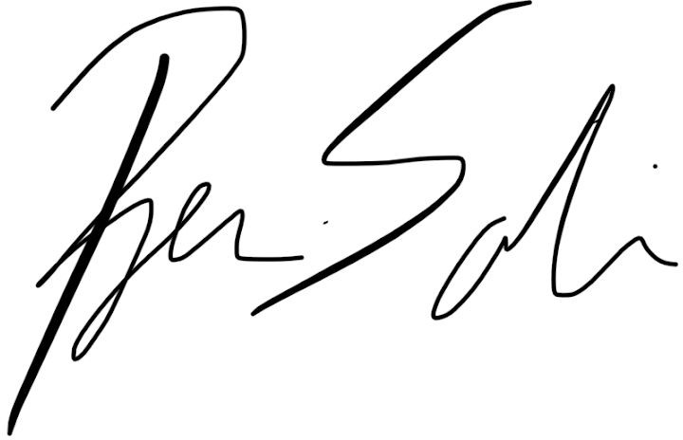
For the Board of Trustees

